



TANGO CORE MODEL

Local data loading process in the application

|  |  |  |  |
| --- | --- | --- | --- |
| Author | Version | Date | Comments |
| Tango CM project team | V0 | 2014/07/03 | Draft version |
| Financial Controlling | V1 | 2014/07/03 | Draft version |
| Tango CM project team | V2 | 2014/07/04 | Minor Corrections |
| Tango CM project team | V3 | 2014/09/11 | Ajout 6.1.2.10 + Final Version |
| Tango CM project team | V3.1 | 2014/09/23 | Minor Corrections |
| Tango CM project team | V4.1 | 2016/03/25 | New version 10.2.2 |
| Tango CM project team | V4.2 | 2016/04/27 | New version 10.2.2 + |
| Tango CM project team | V4.3 | 2017/01/04 | Adjustment for CHL roll-out |

Table of Contents

1. Introduction 3

2. Structuring principles 4

2.1. Structuring principles for Germany, Netherland and USA 5

2.2. Structuring principles for Australia, Canada, Portugal, UK, France and Sweden 5

2.3. Steps 5

2.4. Calendar 7

2.5. Planning process 8

3. How to Extract files (step 1) 9

3.1. Data P&L and Operational extraction files 9

3.2. Metadata P&L extraction file 10

4. How to copy files into the Reception directory (steps 2-3) 11

5. How to launch process (step 4) 12

6. How to check rejects, data and metadata (step 8) 14

6.1. How to check rejects 14

**6.1.1.** Turbo Integrator messages 14

**6.1.2.** Errors identification and correction 16

6.2. How to check data 19

7. Who contacting 20

8. How to connect 21

9. Annexes 22

9.1. Annexes for Australia & New Zealand, Canada, Portugal, France, UK and Sweden 22

**9.1.1.** Data P&L and Operational extraction file 22

**9.1.2.** Chores 23

9.2. Annexes for Germany 24

**9.2.1.** Data P&L and OPE extraction file for Germany 24

**9.2.2.** Chores 25

9.3. Annexes for Netherland 25

**9.3.1.** Data P&L and OPE extraction file for Netherland 25

**9.3.2.** List of Chores for NL_TM1 and NL_Exact 29

9.4. Annexes for USA 29

**9.4.1.** Data P&L and OPE extraction files for USA 29

**9.4.2.** Chores for USA 32

# Introduction

Tango Core Model is a performance management tool that aims at sharing among Transdev Group the same vision of Performance Management through:

* The reconciliation of operational and financial performance
* The improvement of local and central performance management

Tango Core Model is supported by an IBM software (TM1 Cognos 10.2.2 FP4).

It is based on :

* A common language and management framework basis for management dialogue and performance monitoring
* Common definition of “activities”
* Common financial indicators based on a shared analytical P&L and aggregates
* Redefined operational KPIs and Work units articulated with P&L
* A common management axis, adapted to each country’s specific requirements

Part of Tango data is retrieved through interfaces with the local performance management tools.

**Country IT departments are responsible for the development of extraction semi-interfaces from the local performance management tools.**

**This document specifies the extraction semi-interfaces to be maintained by country IT departments**. Those specifications have been designed and validated with country representatives.

This document aims at:

* Presenting the structuring actions to be done by countries in terms of loading data into Tango
* Formalizing the Core model functional and technical aspects of Tango’s interface

# Structuring principles

Tango Core Model collects data from local management tools (by interface and/or manual input thanks to dedicated input report) and from Vector.

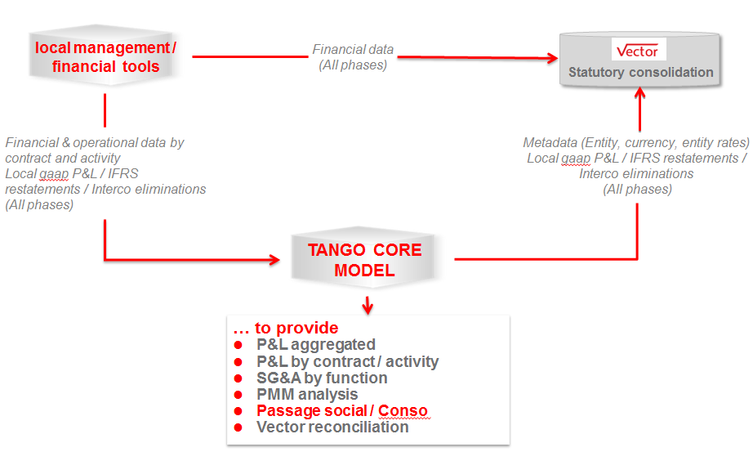

Countries will have to provide **at the specified format** (**in Tango Core Model format) and at the lowest level of each input dimensions** for all phases (actual, budget and forecast) and by source :

* **An extraction file with financial data**
* **An extraction files with operational data**

Data has to be provided through flat files (DSV* files or csv files, separator semicolon):

* + Extracted monthly in local currency (units) and in cumulative data (Year To Date):
  + Feeding for financial and operational data : See the planning process §2.5
  + Between D+5 (closing deadline) and D+16 (end of closing) the Vector Actual data will be refreshed every two business days to give the option to the countries to update (if necessary) their financial figures and to provide new .csv files for.
  + For Budget and Forecast 1 & 2, financial data shall be provided on a monthly basis (compulsory) according to the group Budget & Forecasts instructions. The data loading processes have to be be manually launched using dedicated chores.

* DSV : Delimiter separated values

The feeding of data files adds and replaces existing data with the new file data.



## Structuring principles for Germany, Netherland and USA

To reduce the workload for countries, the extraction is done with local dimensions and codes. The correspondence with Tango dimensions and codes is managed in tango through mapping tables.

These mappings have been designed with the countries active support and its maintenance is under the responsibility of each country.

Hence, these countries have to manage locally :

* + The mapping definition between local dimensions and Tango’s,
  + The extraction of data from local tools in Tango format (transactional, management or operational tools),
  + Transfer to Tango environment
  + The mapping loading in Tango CM
  + The data loading in Tango CM

## Structuring principles for Australia, Canada, Portugal, UK, France and Sweden

For Australia, Canada, Portugal, UK, France and Sweden, the transformation of local data in Tango CM format can be directly manage in local management tools. In this case, the transformation should precede the extraction. This requires the update of local tools to integrate Tango dimensions and mappings.

Hence, these countries have to manage locally :

* + The mapping definition between local dimensions and Tango’s,
  + The extraction of data from local tools (transactional, management or operational tools),
  + The transformation in Tango format.
  + Transfer to Tango environment
  + The data loading in Tango CM

## Steps

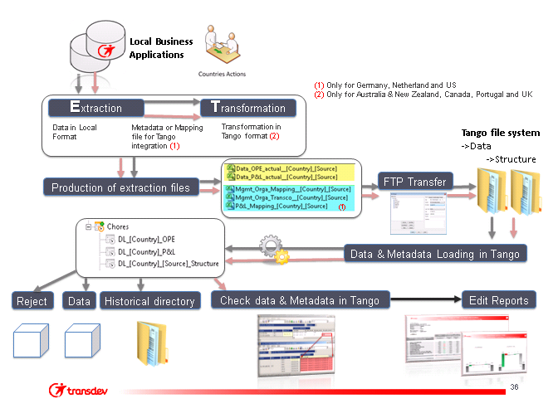

**8**

**7**

**6**

**5**

**3**

**9**

**4**

**1**

**2**

* Task 1 : The user has to extract data into .csv file (mapping & data)
* Task 2: The user has to copy the flat files into the **Reception directory**.
* Task 3 : Flat files are copied into the Process directory by The FTP server
* Task 4 : The user has to launch processes to load data into Tango
* Task 5 : Rejected data are loaded into the reject cube by Tango Application
* Task 6 : Data are loaded into Tango Application
* Task 7: After loading, tango application copies the csv files into the historical directory
* Task 8 : The user has to check rejects, data and Metadata in Tango
* Task 9 : Once all previous steps are completed, the user can edit reports in order to control the quality of their data

## Calendar

This calendar is communicated by finance corporate to countries once a year along with financial consolidation deadlines.

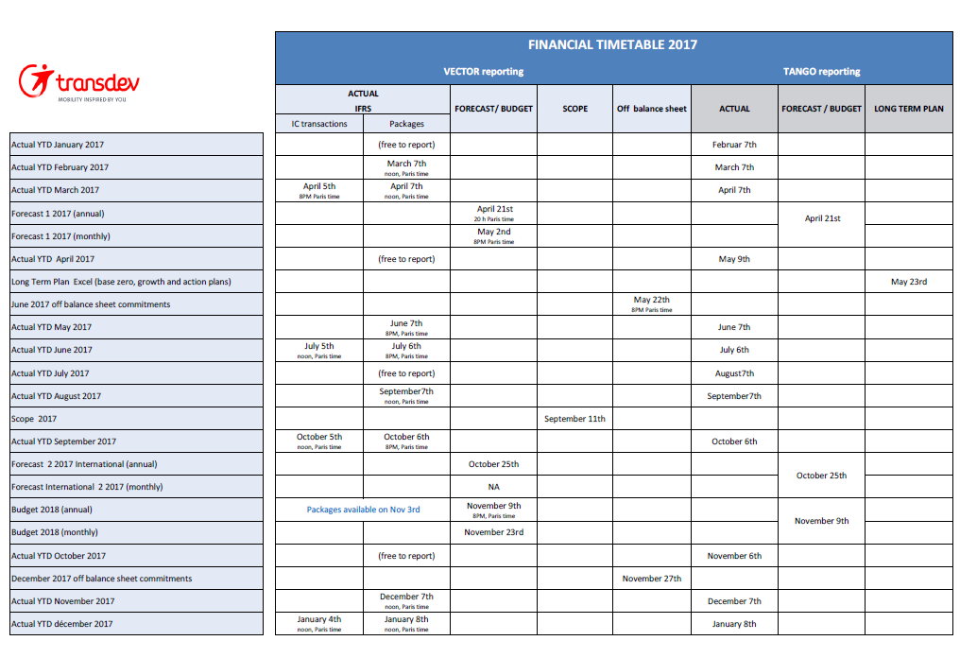

## Planning process

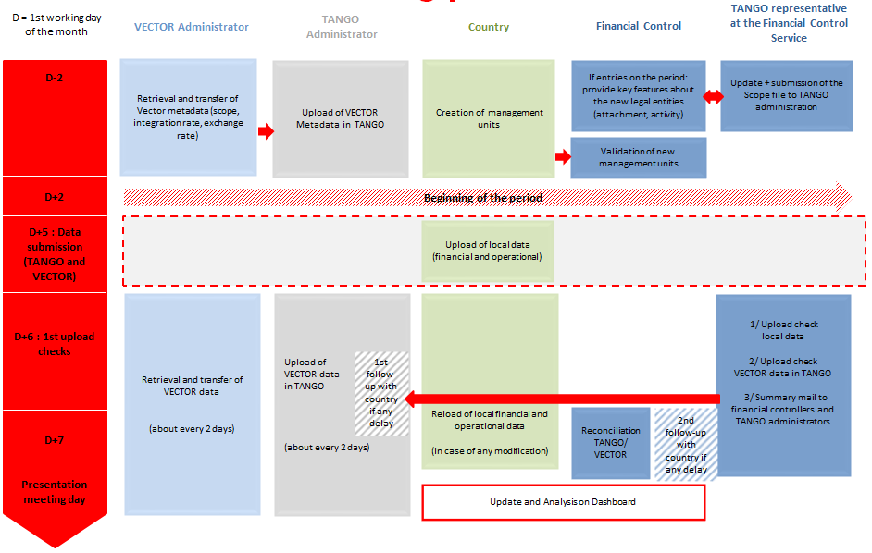

# How to Extract files (step 1)

## Data P&L and Operational extraction files

Extraction files produced by countries for local financial and operational data loading into Tango **must respect a defined format (set of columns)** to be run by the TM1 process.

Countries manage the extraction depending on local decisions based on technical and functional aspects.

All dimensions (columns) must be filled.

**The columns sequence must be respected and the first line of the file is used for column headers** (see Annexes for technical structures)**.**

**Rules for file structure** :

1st line :  Columns Headers

2nd to last line : Data

List separator : " ; " [Semicolon]

Decimal symbol : " , "  [coma] (*)

Number of digits after decimal 2 advised (0 to 6 accepted)

Digit grouping : None

Digit grouping symbol : None

Negative sign symbol : " - "

Negative number format : -1,99999 (*)

Display leading Zero : Yes 0,99 (*)

Display Null values : No

End of Line : CR/LF (windows)

(*) For USA (Oracle & JDE), decimal symbol = " . "

**!! Caution !!**

**Be careful when using Excel to build your extraction files, Excel uses your local/regional settings to format numerical values, list separators and decimal symbol.**

**Once the file has been produced, edit it with notepad to checks that the format is compliant with Tango Requirements.**

**Actual files must contain current month YTD data.**

**Forecast and Budget files must contain monthly YTD data (January to december)**

Extraction files produced by countries for local financial data loading into Tango **must respect the defined naming convention:**

* **For Actual** : Data_P&L_Actual_”country”.csv
* **For Budget** : Data_P&L_Budget_"country”.csv
* **For Forecast 1** : Data_P&L_Forecast_1_”country”.csv
* **For Forecast 2** : Data_P&L_Forecast_2_”country”.csv

Extraction files produced by countries for local operational data loading into Tango **must respect the defined naming convention:**

* **For Actual** : Data_OPE_Actual_”country”.csv
* **For Budget** : Data_OPE_Budget_"country”.csv
* **For Forecast 1** : Data_OPE_Forecast_1_”country”.csv
* **For Forecast 2** : Data_OPE_Forecast_2_”country”.csv

***Country***

***AUS_NZ*** *for Australia and New Zealand*

***CAN*** *for Canada*

***FR*** *for France*

***GE_CognosExpress*** *for Germany*

***NL_TM1*** *for the Netherland(Connexxion)*

***NL_Exact*** *for the Netherland(VTNL)*

***POR*** *for Portugal operational units figures*

***POR_Hold*** *for Portugal holding units figures*

***SW*** *for Sweden units figures*

***UK*** *for United Kingdom*

***US_JDE*** *for USA(specify Transit or On demand)*

***US_ORACLE*** *for USA(specify Transit or On demand)*

***CHL*** *for Chile assumptions*

## Metadata P&L extraction file

**These files only concern Germany, Netherland and USA.**

Each country will provide monthly a file with local codes. Among these codes, some will have to be transcodified in order to match local management tools codes and Tango codes.

This transcodification is handled through mapping tables.

These mapping tables will be managed in Tango, but updated by the countries when necessary. **There is an update possibility of these mapping tables which is under the responsibility of each country.**

The mapping is adapted to all countries and will contain only the columns that the country really needs to fill.

# How to copy files into the Reception directory (steps 2-3)

***Note:*** *Informations presented bellow are based on the use of FileZilla (Group standard FTP client) but can be transpose to any other FTP client.*

**(1) Fill the FTP host, the country ID, the password and the port then click on [Quickconnect] button**

**(2) Drag & Drop your csv file from your local site to the distant site (/in/Tango/Corporate)**

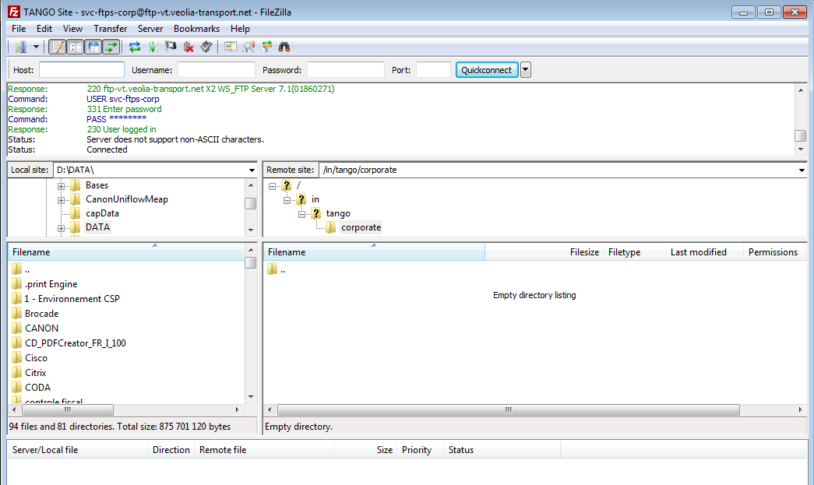

**(2)**

**(1)**

When the extraction file is on the reception directory:

* It is automatically transferred to Tango (The only manual action that you have to do is the file deposit on the reception directory)
* It can take up to 15 minutes to transfer the file into Tango loading directory

See the documentation “TANGO FTP Transfer.docx” for more details

# How to launch process (step 4)

A chore is a collection of processes that can be launched to run several processes with a single action. In order to load data into Tango, dedicated chores have been defined.

Countries have to launch the chores and check the loading status, to correct reject causes (if any) and to validate the correct loading of local data *(check and validate the consistency of Tango data with local management tool through Tango standard reports or cube views)*

In Tango, drill down “Chores” menu and launch chores one after the other for current phase (see the list of chores by country in 9.Annexes).

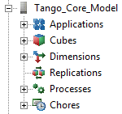

To launch the chore, click on [Run] in the right-click menu.

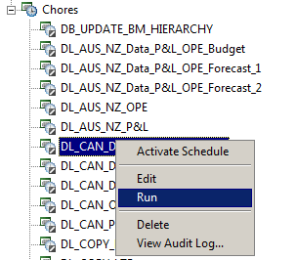

At the end of the process running, 2 different messages can be displayed:

* “Process completed successfully”

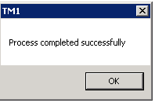

* “Process failed”

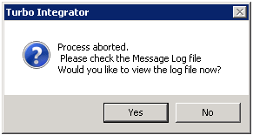

In that case, see how to check rejects in chapter How to check Data Rejects

# How to check rejects, data and metadata (step 8)

## How to check rejects

### Turbo Integrator messages

#### Process aborted



This message means that the process has been aborted because errors during the process running. Errors can come from extraction file that cannot be opened or when specified process value parameters are not valid.

In this case, click on “YES” to consult the log message.

***Note****: the log message can also be displayed by selecting “log message” in the right-clicking menu on “Tango_Core_Model”.*

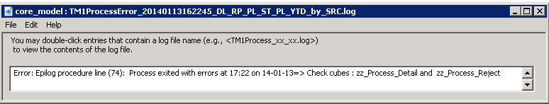

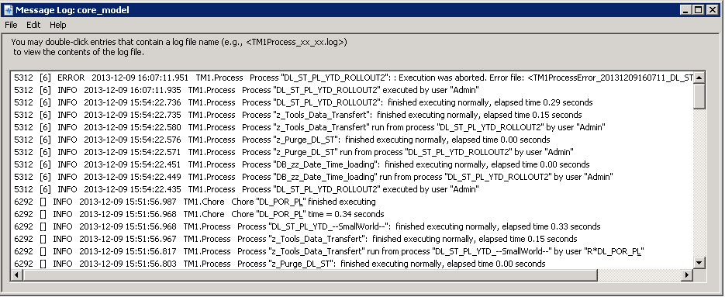

The first ERROR line has a log message; you have to double click on it to be able to read the detail of the error log message.

See different kind of errors in chapter 6.1.2

#### Process completed with minor errors

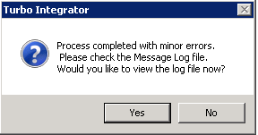

This message means that the process is completed with minors errors.

In this case, click on “YES” to consult the log message, identify and address the mistakes in the extraction file.

In some cases, data will be loaded in reject_element of input dimensions.

In some other cases, there will be no need for corrections *(e.g. even if the element does not exist in Gaap dimension, data will be loaded “Local_Gaap_mgmt_tool”)*

#### “Process failed by Process Quit function”

This message means that the process is aborted by a specific function which defined consistency controls between the selected process parameters and the extraction file elements:

- Legal organization : Extraction file Entity is not consistent with the selected source in the parameters

- Indicators : The element is not a detailed level of the dimension/ The element does not exist in the indicator dimension. The data will be loaded on element reject/Type of indicators expected (Financial; operational) vs. selected process parameter

- Phase : The Phase doesn't correspond to the selected process parameter

### Errors identification and correction

#### Check reject cubes

In case of rejects into the ZZ_Process_Detail_By_Source cube, opening a view on zz_process_reject_By_Source cube allows the identification of the reject cause.



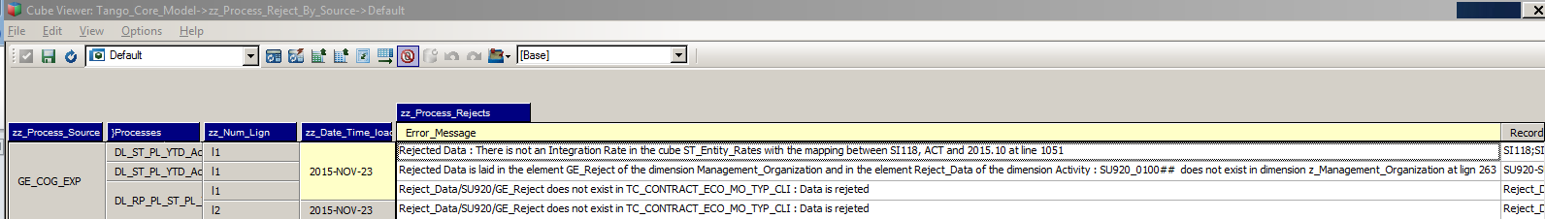

In case of rejects into the ZZ_Process_Detail_cpp cube, opening a view on zz_process_reject_cpp cube allows the identification of the reject cause.



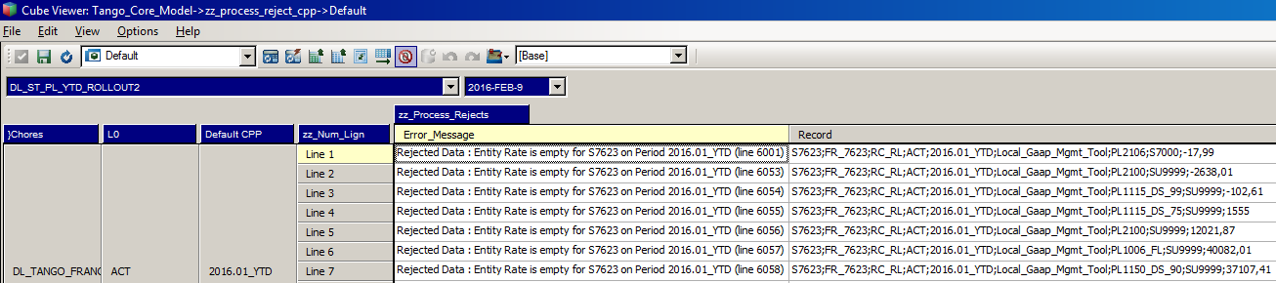

#### File cannot be found

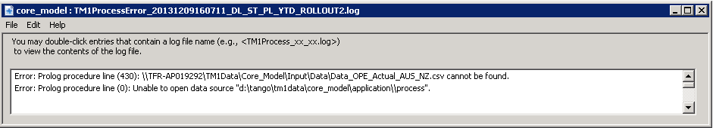

Possible causes:

- The file does not exist in the repertory

- The file does not exist in the repertory for the process because the convention name is not respected;

- The file is opening during the process execution

#### Specified value parameters is not valid

E.g. the source entity “PO” value entered in the prompt is not valid

Parameters are automatically filled in for chores. See with Tango Core Model administrator to resolve this error.

#### Tango indicator unknown in Indicator dimension

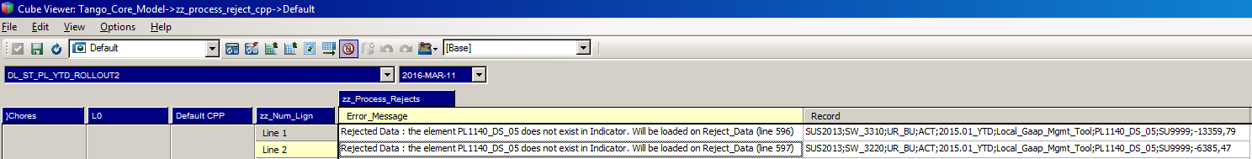

If the Tango indicator is unknown in Indicator dimension, the source system administrator must correct this indicator in the Mapping_PL_xx_xxxx.csv flat file. Then he sends this file in Tango system. The next day, this new mapping will be loaded in transcodification cube.

#### Field defined Not null is empty

If the field defined Not Null is empty, correction must be done in the flat file by source system administrator. Then he sends this file in Tango system. The next day, this new file will be loaded in the Tango system.

#### Entity unknown in Legal_Organization dimension

First of all, it is necessary to be sure that the legal organization in the data file is the right one. If not, the data file has to be modified.

Otherwise, if the entity is unknown in Legal_Organization dimension, an element is missing in the dimension. Then, the Tango administrator has to update the legal_organisation.csv file. Once the .csv file for Legal_Organization dimension is updated, the DB_Legal_organization process has to be executed by the administrator.

Obviously, as the Legal_Organization element does not exist during the loading process, no data have been loaded. Therefore the flat data file need to be sent the next day to be reloaded.

#### Management unit unknown in Management Unit dimension

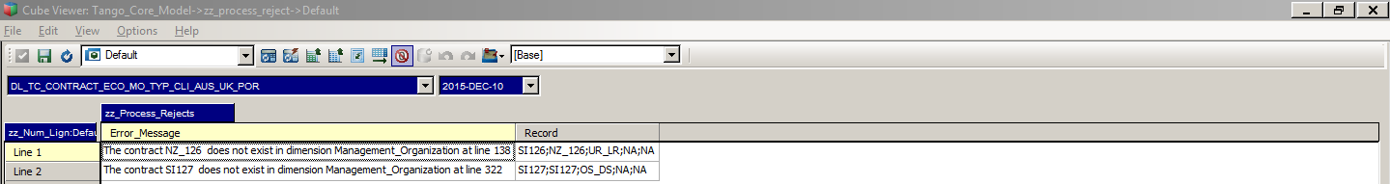

If the Management Unit is unknown in Management Unit dimension, the source system administrator must create this management unit with management input report. After he must send the flat file the next day to load data.

#### Management unit unknown in TC_CONTRACT_ECO_MO_TYP_CLI

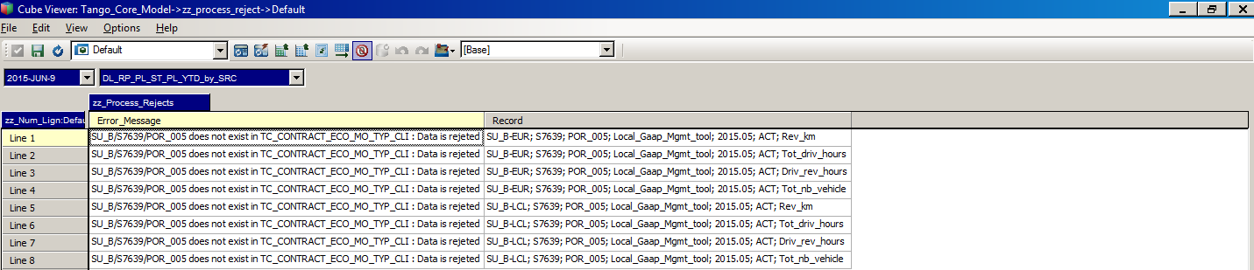

The crossing between the legal organization, the management organization and the activity does not exist in the cube.

Contact Tango administrator to make the crossing available.



#### Source indicator unknown in mapping P&L indicator file

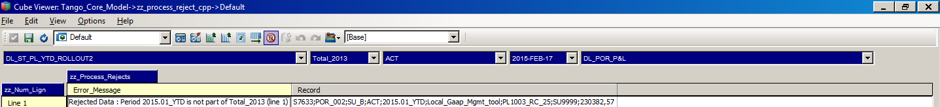

In this context, Mapping_PL_xx_xxxx.csv has to be completed by the Country project Manager . Then, this file with the financial data has to be sent into the reception directory in order to reload them the next day.

#### Periode in parameter different of the period in the file

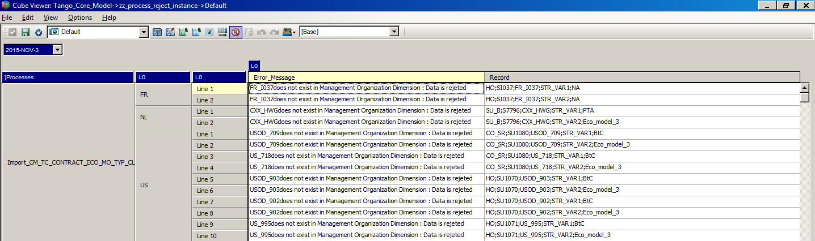

Period in file “country”_Data_ST_Partner_YTD.csv is period of last loaded data.

If no data has been loaded for the current period, period in file ”country”_Data_ST_Partner_YTD.csv is the previous period.

## How to check data

**After reject corrections (if any), check and validate all data through Tango standard reports or cube views : consistency with data in local management tool and Vector.**

User has to check in theses 2 cubes to identify the errors messages :



US, GER and NL have to check the loading status into the ZZ_Process_Detail_By_Source cube after processes running and check the number of reject records.

Others countries have to check the loading status into the ZZ_Process_detail_cpp cube after processes running and check the number of reject records.

# Who contacting

For support, your contacts are :

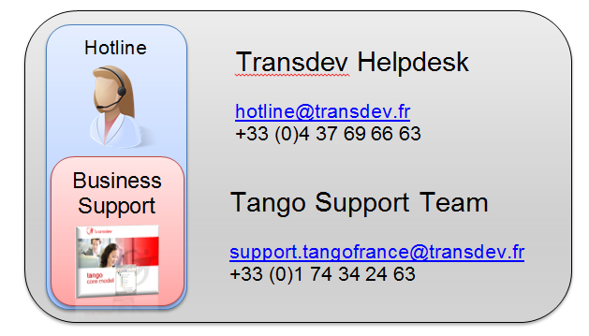

+33 (0)1 74 34 28 96

# How to connect



# Annexes

## Annexes for Australia & New Zealand, Canada, Portugal, France, UK and Sweden

### Data P&L and Operational extraction file

**The columns sequence must be respected and the first line of the file is used for column headers.**

|  |  |  |  |
| --- | --- | --- | --- |
| **Source dimension in local performance management tool** | **Type and lenth** | **Nullable** | **Comments** |
| **Legal_Organization** | Varchar | N | Vector Entity code |
| **Management_Organization** | Varchar | N | *(e.g. CHL_001)* |
| **Activity** | Varchar | N | Tango activity Code |
| **Phase** | Varchar | N | **It must be conform at detailled design of technical axes** |
| **Period** | Varchar | N |  |
| **GAAP** | Varchar | Y | **It must be conform at detailled design of technical axes**  Leave empty for operational indicator extraction |
| **Indicator / Measure** | Varchar | N | Tango indicator code |
| **Partner** | Varchar | Y | Vector Entity code  **Leave empty for operational indicator extraction** |
| **Amount / Value** | Numeric(15,2) | N | Should be negative for charges and positive for products |

Technical axis in Tango are not deducted from mapping tables, but from rules defined in Tango.

Those rules are based on the codification described in the table below. Extractions must respect the expected values & formats:

|  |  |
| --- | --- |
| **Source dimension in local performance management tool** | **Expected value and formats** |
| **Phase** | ACT  BUDG_VC  FC_1_VC  FC_2_VC |
| **Period** | YYYY_MM_YTD (e.g 2014.06_YTD) |
| **Currency** | CLP |
| **GAAP** | Local_Gaap_Mgmt_tool  0RESIXX (e.g 0RESI025) |

### Chores

#### Chores for Australia

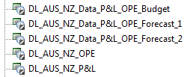

**You should only launch chores for current phase**.

DL_AUS_NZ_OPE and DL_AUS_NZ_P&L are for ACTUAL phase.

#### Chores for Canada

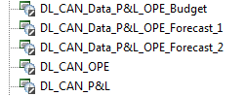

**You should only launch chores for current phase**.

DL_CAN_OPE and DL_CAN_P&L are for ACTUAL phase.

#### Chores for Portugal

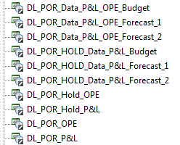

**You should only launch chores for current phase**.

DL_POR_Hold_P&L , DL_POR_OPE and DL_POR_P&L are for ACTUAL phase.

#### Chores for UK

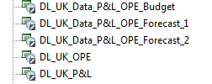

**You should only launch data chores for current phase**

DL_UK_OPE and DL_UK_P&L are for ACTUAL phase.

#### Chores for Sweden

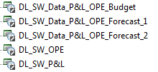

**You should only launch data chores for current phase**

DL_SW_OPE and DL_SW_P&L are for ACTUAL phase.

#### Chores for Chile

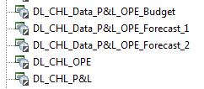

**You should only launch chores for current phase**.

DL_CHL_OPE and DL_CHL_P&L are for ACTUAL phase.

## Annexes for Germany

### Data P&L and OPE extraction file for Germany

**The columns sequence must be respected and the first line of the file is used for column headers.**

|  |  |  |  |
| --- | --- | --- | --- |
| **Source dimension in local performance management tool** | **Type and lenth** | **Nullable** | **Comments** |
| **Entity** | Varchar | N | Vector Entity code |
| **Cost center** | Varchar | N |  |
| **Phase** | Varchar | N | **It must be conform at detailled design of technical axes** |
| **Currency** | Varchar | Y | **Leave empty for operational indicator extraction file** |
| **Account** | Varchar | N | **Use for local financial or operational indicator code** |
| **GAAP** | Varchar | Y | **It must be conform at detailled design of technical axes**  Leave empty for operational indicator extraction file |
| **Partner** | Varchar | Y | Vector Entity  **Leave empty for operational indicator extraction file** |
| **Month** | Integer | N |  |
| **Year** | Integer | N |  |
| **Amount** | Numeric(15,2) | N |  |

**The codes used in the extraction must be the local codes, respecting the codes in the mapping tables**

Technical axis in Tango are not deducted from mapping tables, but from rules defined in Tango.

Those rules are based on the codification described in the table below. Extractions must respect the expected values & formats :

| **Source dimension in local performance management tool** | **Expected value and formats** |
| --- | --- |
| **Phase** | actual  budget  fc1  fc2 |
| **Month** | MM (e.g 01) |
| **Year** | YYYY (e.g. 2012) |
| **Currency** | EUR |
| **GAAP** | HGB  IFRS adjustment |

### Chores

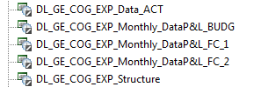

**Chore of Structure should be launched FIRST regardless of the phase to be proceeded.**

**You should only launch data chores for current phase** (ACT for Actual, BUDG for Budget, FC_1 for Forecast 1 and FC_2 for Forecast_2).

## Annexes for Netherland

### Data P&L and OPE extraction file for Netherland

#### Data P&L and OPE extraction file for NL_TM1

**The columns sequence must be respected and the first line of the file is used for column headers.**

| **Source dimension in local performance management tool** | **Type and lenth** | **Nullable** | **Comments** |
| --- | --- | --- | --- |
| **Vector Entity** | Varchar | N | Vector Entity code |
| **Management unit** | Varchar | N | Tango Management Unit code |
| **Phase** | Varchar | N | **It must be conform at detailled design of technical axes** |
| **Currency** | Varchar | Y | Leave empty for operational indicator extraction file |
| **Account number** | Varchar | Y | **Use for financial indicator code** |
| **GAAP** | Varchar | Y | **It must be conform at detailled design of technical axes**  Leave empty for operational indicator extraction file |
| **Partner** | Varchar | Y | Vector Entity code  **Leave empty for operational indicator extraction file** |
| **Periode & Year** | Varchar | Not null |  |
| **Amount** | Numeric(15,2) | Not null |  |

Technical axis in Tango are not deducted from mapping tables, but from rules defined in Tango.

Those rules are based on the codification described in the table below. Extractions must respect the expected values & formats:

|  |  |
| --- | --- |
| **Source dimension in local performance management tool** | **Expected value and formats** |
| **Phase** | Actual  Budget  Forecast_1  Forecast_2 |
| **Period and Year** | YYYY.MM (e.g. 2012.02) |
| **Currency** | EUR |
| **GAAP** | IFR |

#### Data P&L and OPE extraction file for NL_Exact

**The columns sequence must be respected and the first line of the file is used for column headers.**

| **Source dimension in local performance management tool** | **Type and lenth** | **Nullable** | **Comments** |
| --- | --- | --- | --- |
| **Vector Entity** | Varchar | N | Vector Entity code |
| **Management unit** | Varchar | N | Local Management Unit Code |
| **Phase** | Varchar | N | **It must be conform at detailled design of technical axes** |
| **Currency** | Varchar | Y | Leave empty for operational indicator extraction file |
| **Account number** | Varchar | N | **Use for local financial or operational indicator code** |
| **Cost_Center** | Varchar | Y | Leave empty for operational indicator extraction file |
| **Destination_Code** | Varchar | Y | Leave empty for operational indicator extraction file |
| **GAAP** | Varchar | Y | **It must be conform at detailled design of technical axes**  Leave empty for operational indicator extraction file |
| **Partner** | Varchar | Y | Vector Entity code  **Leave empty for operational indicator extraction file** |
| **Periode** | Integer | N |  |
| **Year** | Integer | N |  |
| **Amount** | Numeric(15,2) | N |  |

Technical axis in Tango are not deducted from mapping tables, but from rules defined in Tango.

Those rules are based on the codification described in the table below. Extractions must respect the expected values & formats:

|  |  |
| --- | --- |
| **Source dimension in local performance management tool** | **Expected value and formats** |
| **Phase** | Actual  Budget  FC1YYYY  FC2YYYY |
| **Period** | Main figure of the month (e.g 1 or 12) |
| **Year** | YYYY (e.g. 2012) |
| **Currency** | EUR |
| **GAAP** | Local_Gaap_Mgmt_tool |

### List of Chores for NL_TM1 and NL_Exact

#### List of Chores for NL_TM1 and NL_Exact

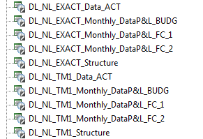

**Chore of Structure should be launched FIRST regardless of the phase to be proceeded.**

**You should only launch data chores for current phase** (ACT for Actual, BUDG for Budget, FC_1 for Forecast 1 and FC_2 for Forecast_2).

## Annexes for USA

### Data P&L and OPE extraction files for USA

#### Data P&L and OPE extraction file for US_JDE

**The columns sequence must be respected and the first line of the file is used for column headers.**

| **Source dimension in local performance management tool** | **Type and length** | **Nullable** | **Comments** |
| --- | --- | --- | --- |
| **Vector Entity** | Varchar | N | Vector Entity code |
| **Management unit** | Varchar | N | Local Management Unit code |
| **Phase** | Varchar | N | **It must be conform at detailled design of technical axes** |
| **Currency** | Varchar | Y | Leave empty for operational indicator extraction file |
| **Object** | Varchar | N | Local code |
| **Sub Account** | Varchar | Y | Leave empty for operational indicator extraction file |
| **Allaccounts (1/2/3)** | Varchar | Y | Leave empty for operational indicator extraction file |
| **GAAP** | Varchar | Y | **It must be conform at detailled design of technical axes**  Leave empty for operational indicator extraction file |
| **Partner** | Varchar | Y | Vector Entity code  **Leave empty for operational indicator extraction file** |
| **Periode** | Integer | N |  |
| **Year** | Integer | N |  |
| **Amount** | Numeric(15,2) | N |  |

Technical axis in Tango are not deducted from mapping tables, but from rules defined in Tango.

Those rules are based on the codification described in the table below. Extractions must respect the expected values & formats:

|  |  |
| --- | --- |
| **Source dimension in local performance management tool** | **Expected value and formats** |
| **Phase** | AA / AH  BS / BH  F1  F2 |
| **Allaccount** | AC1  AC2  AC3 |
| **Period** | 1 figure for the months between January and September (1 through 9) and 2 figures for the months between October and December (10 through 12) |
| **Year** | YY (e.g. 12) |
| **Currency** | USD |
| **GAAP** | Local_Gaap_Mgmt_tool |

**The columns sequence must be respected and the first line of the file is used for column headers.**

| **Source dimension in local performance management tool** | **Type and length** | **Nullable** | **Comments** |
| --- | --- | --- | --- |
| **Vector Entity** | Varchar | N | Vector Entity code |
| **City** | Varchar | N |  |
| **Cost Center** | Varchar | Y |  |
| **Phase** | Varchar | N | **It must be conform at detailled design of technical axes** |
| **Currency** | Varchar | Y | Leave empty for operational indicator extraction file |
| **Account** | Varchar | N | Local code |
| **GAAP** | Varchar | Y | **It must be conform at detailled design of technical axes**  Leave empty for operational indicator extraction file |
| **Periode & Year** | Varchar | N |  |
| **Amount** | Numeric(15,2) | N |  |

Technical axis in Tango are not deducted from mapping tables, but from rules defined in Tango.

Those rules are based on the codification described in the table below. Extractions must respect the expected values & formats :

|  |  |
| --- | --- |
| **Source dimension in local performance management tool** | **Expected value and formats** |
| **Phase** | ACT  BUDG  FC_1  FC_2 |
| **Period & Year** | YY–MMM (e.g. 12–JAN) |
| **Currency** | USD |
| **GAAP** | Local_Gaap_Mgmt_tool |

### Chores for USA

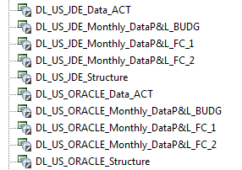

**You should only launch data chores for current phase** (ACT for Actual, BUDG for Budget, FC_1 for Forecast 1 and FC_2 for Forecast_2).

**Chores of Structure should be launched in all phases.**